Notice of Public Information Centre
Thunder Bay Road Upgrades

The Town of Fort Erie has initiated engineering design for the Thunder Bay Road Upgrades Project. The project area is located along Thunder Bay Road from Burleigh Road South to Prospect Point Road South. The general scope of work for this project includes full reconstruction and upgrade of the existing Thunder Bay Road right-of-way to an urban cross-section including installation of storm sewer infrastructure, new sidewalks and concrete curb and gutter. In addition, replacement of the existing 300mm diameter cast iron watermain along Thunder Bay Road between Burleigh Road South and Prospect Point Road South.

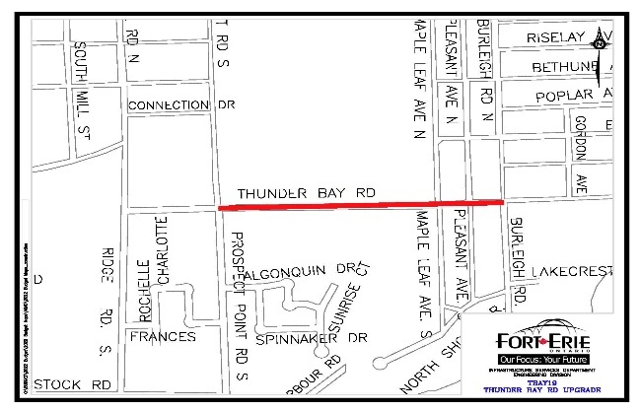

Public consultation of the proposed design is an important component of the project. Public consultation for Thunder Bay Road will be conducted online through the website found below. This online viewing is being held to provide interested parties with an opportunity to review the design and construction plans. This is a pre-approved Schedule A+ Municipal Class Environmental Assessment (MCEA) project. Those who wish to comment on the project can do so by completing the online survey or by contacting the Project Team. The design drawings will be available for viewing and comment from:

Monday November 11th, 2024 to Friday November 29th, 2024 at the following website:
letstalk.forterie.ca

Select: Public Consultation for Thunder Bay Road Upgrade

If you would like to learn more about the project and are unable view the online PIC, please contact:

Adam Keane, P.Eng Mitch Sawatsky
Engineering Manager Project Manager- Engineering
Upper Canada Consultants Town of Fort Erie
Phone: 905-688-9400 Phone: 905-871-1600, Ext. 2413
Email: adam@ucc.com Email: msawatsky@forterie.ca

Information will be collected in accordance with the Municipal Freedom of Information and Protection of Privacy Act. With the exception of personal information, all comments will be part of the public record.

